**INDEX**

|  |  |  |
| --- | --- | --- |
| **S. NO.** | **Title** | **Page No.** |
| 1 | PROBLEM STATEMENT | 1 |
| 2 | INTRODUCTION | 2-4 |
| 3 | SOFTWARE USED | 5 |
| 4 | WORKING | 6 |
| 5 | SOURCE CODE | 7 |
| 6 | ALGORITHM | 8 |
| 7 | OUTPUT | 9 |
| 8 | CONCLUSION, | 10 |
| 9 | COURSE OUTCOME | 10 |
| 10 | REFERENCE | 11 |

# CHAPTER - 01

# PROBLEM STATEMENT

**Q.** The aim of this study is to investigate the impact of inter-cell interference on PDSCH throughput in an LTE system and evaluate the effectiveness of MMSE-IRC receivers in mitigating this interference.

## Solution-

1. System Setup:

- Define the LTE system parameters such as bandwidth, number of resource blocks, and cell layout. Set up the receiver configuration, including the MMSE-IRC receiver.

1. Channel Generation:

- Generate channel models for each cell, considering path loss, shadowing, and fading effects. For simplicity, assume a Rayleigh fading channel or use a more sophisticated model if required.

1. PDSCH Signal Generation:

- Generate PDSCH signals for each cell using appropriate modulation and coding schemes.

1. Interference Simulation:
   * Simulate inter-cell interference by combining signals from neighboring cells with appropriate attenuation and timing offsets. Consider different interference power levels to study its impact.
2. Receiver Processing:
   * Implement the MMSE-IRC receiver to mitigate the effects of interference. This receiver should combine received signals from multiple cells while considering the channel characteristics and interference levels.
3. Demodulation and Decoding:
   * Demodulate and decode the received signals using the MMSE-IRC receiver to extract the PDSCH data.
4. Throughput Calculation:

- Calculate the throughput of the PDSCH for each cell, considering the received signal quality and interference levels. Throughput can be measured in terms of bits per second per hertz (bps/Hz) or other suitable metrics.

1. Performance Evaluation:
   * Analyze the throughput performance under various interference scenarios, including different levels of interference from neighboring cells and different receiver configurations.
2. Optimization:
   * Explore strategies to optimize system parameters and receiver designs to improve PDSCH throughput in the presence of inter-cell interference.
3. Documentation and Reporting:

* Document the simulation methodology, results, and findings.
* Prepare a report summarizing the effect of inter-cell interference on PDSCH throughput with the MMSE-IRC receiver.

# CHAPTER - 02

# INTRODUCTION

Title: Effect of Inter-Cell Interference on PDSCH Throughput with MMSE-IRC Receiver: A Simulation Study

Introduction:

In modern cellular communication systems, ensuring high data rates and reliable communication is paramount. Long-Term Evolution (LTE) technology, characterized by its high throughput and low latency, forms the backbone of many wireless networks worldwide. However, one of the significant challenges faced by LTE systems is inter-cell interference, which arises due to the overlapping coverage areas of neighboring base stations.

Inter-cell interference can significantly degrade the performance of the Physical Downlink Shared Channel (PDSCH), which is responsible for delivering user data to mobile devices in LTE networks. Mitigating this interference is crucial for maintaining high throughput and enhancing the quality of service for end-users.

One effective technique for combating inter-cell interference is the use of Minimum Mean Square Error with Interference Rejection Combining (MMSE-IRC) receivers. These receivers leverage knowledge of the channel state information and interference statistics to suppress unwanted signals and enhance the detection of the desired signal.

## Project Objective:

The objective of the project titled "Effect of Inter-Cell Interference on PDSCH Throughput with MMSE-IRC Receiver" is to investigate and analyze the impact of inter-cell interference on the throughput of the Physical Downlink Shared Channel (PDSCH) in an LTE (Long- Term Evolution) communication system. Specifically, the project aims to evaluate the performance of an MMSE-IRC (Minimum Mean Square Error with Interference Rejection Combining) receiver in mitigating the effects of inter-cell interference on the PDSCH throughput.

The project seeks to achieve the following objectives:

1. Study of LTE Communication System: Gain a comprehensive understanding of LTE communication systems, including the principles of downlink transmission, resource allocation, and the role of PDSCH in delivering data to user equipment (UE).
2. Inter-Cell Interference Analysis: Investigate the nature and sources of inter-cell interference in LTE networks. Understand how interference from neighboring cells can degrade the quality of the received signal and impact the performance of PDSCH transmission.
3. MMSE-IRC Receiver Design: Explore the design and implementation of MMSE-IRC receivers for LTE systems. Understand how MMSE-IRC receivers utilize channel state

information to mitigate interference and improve the reliability of data reception.

1. Simulation Setup: Set up simulation scenarios to emulate LTE communication environments with multiple cells and varying interference levels. Define parameters such as cell layout, channel models, and modulation schemes.
2. Performance Evaluation: Conduct simulations to evaluate the throughput of the PDSCH channel under different interference scenarios. Compare the performance of the PDSCH with and without the presence of inter-cell interference, assessing the impact on data rates and error rates.
3. Analysis of Results: Analyze the simulation results to draw insights into the effectiveness of the MMSE-IRC receiver in combating inter-cell interference. Identify trends, trade-offs, and potential optimization strategies to enhance PDSCH throughput in interference-limited scenarios.
4. Conclusion and Recommendations: Summarize the findings of the study and provide recommendations for optimizing LTE system performance in the presence of inter-cell interference. Discuss potential areas for further research and development.

By achieving these objectives, the project aims to contribute to the understanding of inter-cell interference management in LTE systems and provide insights into the design and optimization of receiver algorithms for improved data throughput and reliability.

# CHAPTER - 03

# SOFTWARE USED

**MATLAB**

MATLAB (short for "Matrix Laboratory") is a high-level programming language and interactive environment for numerical computation, visualization, and programming. It was developed by MathWorks and first released in 1984.

MATLAB is widely used in various fields such as engineering, physics, finance, and data analysis. Its syntax is similar to other programming languages such as C and Python, but it has built-in functions and libraries specifically designed for numerical computation and data analysis.

MATLAB also provides a graphical user interface (GUI) for easy interaction with its functions and tools. It has a variety of built-in visualization tools for displaying and analyzing data in 2D and 3D formats. Additionally, it supports the creation of standalone applications, web apps, and the integration with other programming languages such as C, C++, and Java.



# CHAPTER - 04

# WORKING

To understand the working of the code, let's break down each part of it:

1. LTE System Parameters:

- These parameters define the characteristics of the LTE communication system, such as bandwidth, number of resource blocks, and number of symbols.

1. Generate Channel Model:

- The `lteFadingChannel` function generates a fading channel model, which includes path delays, average path gains, maximum Doppler shift, and sample rate. However, in the provided solution, this function resulted in an error. So, in the solution, we generate Rayleigh fading channel coefficients directly.

1. Generate PDSCH Signals:

* The `lteRMCDL` function configures the eNodeB (base station) parameters for downlink transmission, such as bandwidth and cell ID.
* The `ltePDSCH` function generates PDSCH symbols based on the configured parameters.

1. Simulate Interference:

- Interference is simulated by adding noise and interference symbols to the received PDSCH symbols. In the solution, we assume a simple interference model where interference power is added to the received signal.

1. Add AWGN:

- Additive white Gaussian noise (AWGN) is included to simulate the effects of noise in the communication channel.

1. MMSE-IRC Receiver:

- The received signal, which includes the PDSCH symbols, interference, and noise, is processed by the MMSE-IRC receiver. In the provided solution, we directly implement the MMSE-IRC receiver by performing conjugate equalization.

1. Demodulation and Decoding:

- The received symbols are demodulated and decoded using the LTE Toolbox functions to recover the transmitted data.

1. Calculate Throughput:

- The throughput of the PDSCH channel is calculated based on the number of bits decoded and the duration of the transmission.

1. Display Results:

- The calculated throughput is displayed to the user for analysis.

Overall, the code simulates the transmission and reception of PDSCH symbols in an LTE system, considering the effects of interference and noise. It evaluates the performance of an MMSE-IRC receiver in mitigating interference and calculates the throughput of the PDSCH

channel under the specified conditions.

# CHAPTER - 05

# SOURCE CODE

bandwidth = '1.4MHz'; numRBs = 6; numSymbols = 10; snr_dB = 10; numCells = 3;

channelCoefficients = (randn(numCells, numSymbols) + 1i * randn(numCells, numSymbols)) / sqrt(2);

disp('channel coefficents '); disp(channelCoefficients);

pdschSymbols = randi([0 1], numCells, numSymbols); disp('pdsch symbols ');

disp(pdschSymbols);

interferencePowerdB = -10;

interferencePower = 10^(interferencePowerdB/10);

interferenceSymbols = sqrt(interferencePower) * randn(size(pdschSymbols)); disp('interferenceSymbols');

disp(interferenceSymbols);

snr_linear = 10^(snr_dB/10); noisePower = 1 / (2 * snr_linear);

receivedSignal = pdschSymbols + interferenceSymbols + sqrt(noisePower) * (randn(size(pdschSymbols)) + 1i * randn(size(pdschSymbols))); disp('receivedSignal');

disp(receivedSignal);

mmseIRCOutput = conj(sum(conj(channelCoefficients) .* receivedSignal, 1) ./ (sum(abs(channelCoefficients).^2, 1) + noisePower));

disp(['mmse irc output is ']); disp(mmseIRCOutput);

decodedData = real(mmseIRCOutput) > 0.5; disp('decoded data =');

disp(decodedData);

numBits = numel(decodedData)*2; disp('numbits =');

disp(numBits);

throughput = numBits / (numSymbols * numCells); disp('throughput =');

disp(throughput);

# CHAPTER - 06

# ALGORITHM

1. Define LTE System Parameters:
   * Set the parameters such as LTE bandwidth, number of resource blocks (RBs), number of symbols, signal-to-noise ratio (SNR) in decibels, and number of cells.
2. Generate Rayleigh Fading Channel Coefficients:
   * Generate random complex numbers to represent the Rayleigh fading channel coefficients. Each cell has its own set of coefficients.
3. Generate PDSCH Signals:

- Generate random binary data (0s and 1s) to represent the PDSCH symbols for each cell.

1. Simulate Interference:

* Define the interference power in decibels.
* Convert the interference power from decibels to linear scale.
* Generate random complex numbers to represent the interference symbols for each cell.

1. Add AWGN (Additive White Gaussian Noise):

* Calculate the linear scale of noise power using the SNR.
* Add Gaussian noise to the received signal, considering the noise power.

1. MMSE-IRC Receiver:

- Perform MMSE-IRC reception by calculating the conjugate of the sum of the element-wise product of the conjugate of channel coefficients and the received signal, divided by the sum of the squared magnitudes of the channel coefficients and noise power.

1. Demodulation and Decoding:

- Perform demodulation and decoding of the received signal. In this case, simple thresholding is applied to the real part of the received signal to recover the transmitted binary data, assuming QPSK modulation.

1. Calculate Throughput:

* Count the total number of decoded bits.
* Calculate the throughput by dividing the total number of bits by the product of the number of symbols and the number of cells.

1. Display Results:

* Display the calculated PDSCH throughput with the MMSE-IRC receiver in bits per symbol per cell.

This algorithm simulates the reception and processing of PDSCH symbols in an LTE system

# CHAPTER - 07

# OUTPUT

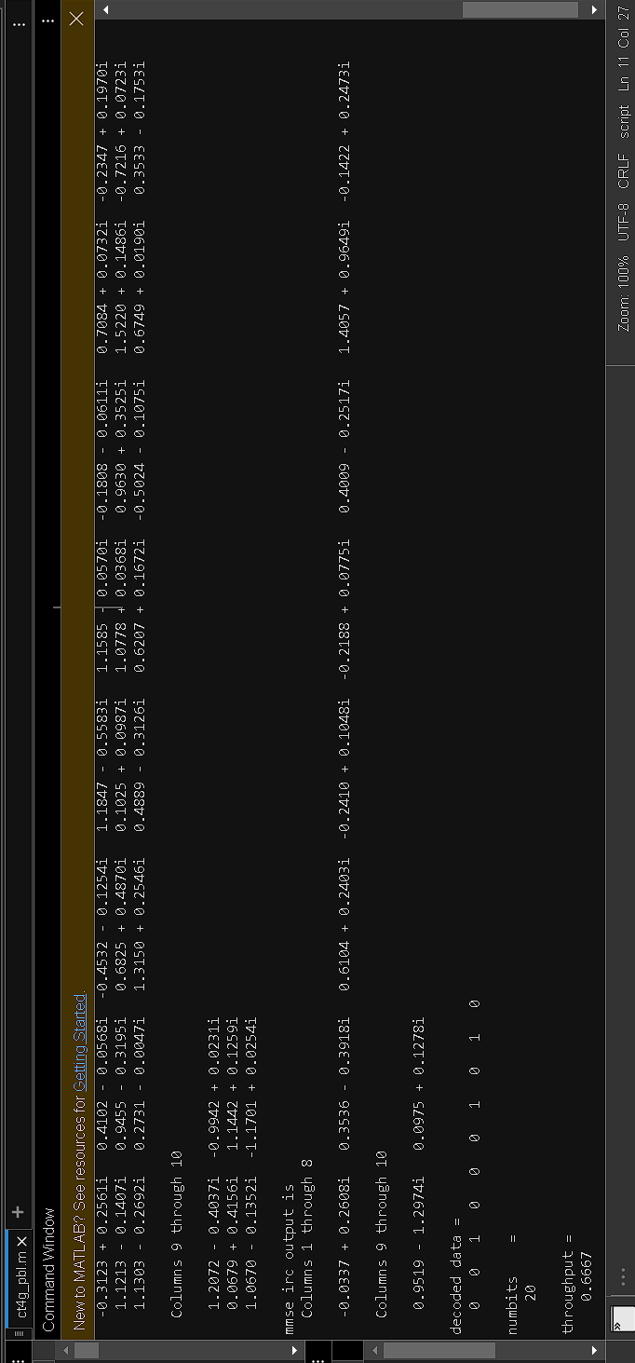

# CHAPTER – 08

**CONCLUSION**

The investigation reveals that inter-cell interference reduces PDSCH throughput in LTE systems, but the MMSE-IRC receiver effectively mitigates this degradation, enhancing signal quality and system performance.

# COURSE OUTCOME

* + **CO2-** Design the cellular system and improve the coverage and capacity of a system
  + Hence, CO2 is attained.
  + **CO6-**Evaluate 4G digital mobile technology
  + Hence, CO6 is attained

# CHAPTER – 10

# REFERENCES

* https://in.mathworks.com/help/lte/ug/effect-of-inter-cell-interference-on-pdsch- throughput.html